MANX FOOTPATHS CONSERVATION GROUP
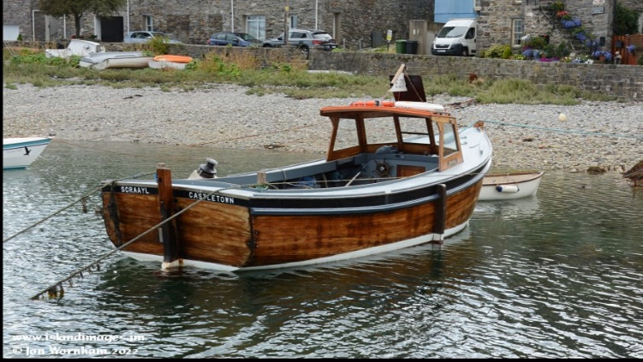
A trip to the Calf on The Scraayl
Wednesday August 7th
Sunday 16th June
Cost £25 p.p.
A full morning to wander around the beautiful
Calf of Man bird sanctuary.
Visit the Victorian Lighthouses, do a bit of bird watching,
chat to the wardens or get a close up view of the seals
and much more…
Members only, numbers strictly limited,
details to follow closer to the time
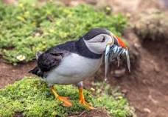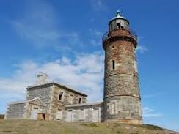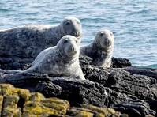
full details on booking

